1. What is AI?
Artificial Intelligence (AI) is the broad field of building systems that can perform tasks that normally require human intelligence, such as understanding language, recognizing patterns, making predictions, solving problems, and supporting decisions. Modern AI includes rule-based systems, machine learning, deep learning, and generative AI.

Venn Diagram
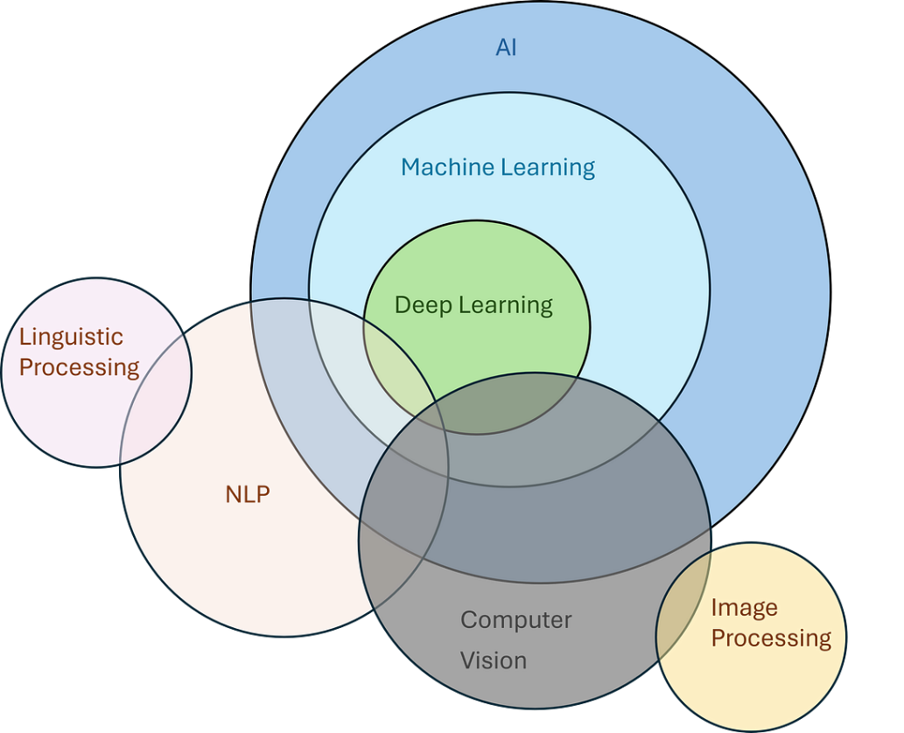
Common AI terminology
The overall field of making computers behave intelligently.
Artificial Intelligence (AI):
AI mimics human intelligence in machines, allowing them to tackle tasks like reasoning, problem-solving, learning, perception, and decision-making. It covers a wide range of techniques and applications, including machine learning, robotics, expert systems, natural language processing, and many more. From fig. 1, we can see that it is the super set for all other mentioned technologies.
The overall field of making computers behave intelligently.

Machine Learning

Deep Learning (DL)
A subset of ML that uses multi-layer neural networks to learn complex patterns from large data.
NLP (Natural Language Processing)
The area of AI focused on understanding and generating human language.
Computer Vision
AI that works with images and videos.
Model
A trained system that takes input and produces output.
Training
The process of teaching a model using data.
Inference
The act of using a trained model to generate an answer or prediction.
Token
A chunk of text a model processes, often a word, subword, punctuation mark, or symbol.
Context window
How much input a model can consider at once.
Hallucination
When a model produces an incorrect or unsupported answer with confidence.
Grounding
Connecting the model’s answer to trusted source material.
Prompt
The instruction or input given to the model.
Tool use
When the model can call external capabilities like search, code execution, databases, or APIs to complete a task. Agent systems are built around this idea.
2. Prompt Engineering
Prompt engineering is the practice of writing instructions so the model gives reliable, useful, and correctly formatted output. OpenAI’s official guidance describes it as writing effective instructions so the model consistently generates content that meets requirements.
Why prompt engineering matters
A good prompt helps you:
- get accurate output
- reduce ambiguity
- control format
- improve consistency
- save time on rework
Good prompt structure
A strong prompt usually includes:
Role
“Act as a Java trainer” or “Act as a business analyst.”
Task
Explain, summarize, generate, classify, compare, review, or rewrite.
Context
Project, audience, domain, constraints, examples.
Output format
Table, bullets, JSON, markdown, interview Q&A, lesson notes.
Quality bar
Beginner-friendly, production-ready, concise, detailed, cite sources, include examples.
Example
Weak prompt:
Explain Java
Better prompt:
Act as a corporate Java trainer.
Explain Java for beginners.
Include: definition, features, JDK/JRE/JVM, real-world use cases, one simple example, and 5 interview questions.
Use simple language and structured headings.
Best practices
Be specific.
Put the important instruction early.
State the audience.
Ask for structure.
Provide examples when possible.
Break complex work into steps.
Ask the model to verify or check assumptions when accuracy matters. These patterns align with current OpenAI prompting guidance and newer prompt guidance focused on completeness, verification loops, and structured outputs.
3. LLMs, GenAI, Agentic AI, and RAG
LLMs
Large Language Models (LLMs) are AI models trained on very large amounts of text so they can understand prompts and generate language, code, summaries, explanations, and transformations. They are powerful, but they do not inherently know your latest private data unless you connect them to it. That is one of the reasons RAG exists.
Generative AI
Generative AI (GenAI) is AI that creates new content such as:
- text
- images
- code
- summaries
- presentations
- chat responses
LLMs are one important kind of generative AI model.
Agentic AI
Agentic AI means using models in a workflow where they can plan, reason over a task, use tools, retrieve information, and sometimes act across multiple steps. OpenAI’s agent guides describe agent building as designing workflows and connecting platform pieces to meet goals, while GitHub Copilot now documents cloud agents that can inspect a repository, create an implementation plan, make changes on a branch, and help open a pull request.
Simple view:
LLM = answers a prompt
GenAI app = uses an LLM to generate useful content
Agent = uses an LLM plus tools, memory, retrieval, and workflow logic to complete tasks across steps
RAG
Retrieval-Augmented Generation (RAG) is a design pattern where the system first retrieves relevant information from trusted data sources and then gives that information to the model so the answer is grounded in that content. Microsoft’s current documentation describes RAG as combining search with LLMs so responses are grounded in your data and especially useful when you need private or frequently changing information.
Why RAG is important
RAG helps with:
- enterprise knowledge search
- policy and document Q&A
- latest or changing information
- reducing hallucinations
- answering from internal content instead of only model memory
Simple flow of RAG
User asks question
→ system searches knowledge base
→ relevant chunks are retrieved
→ chunks are added to prompt
→ LLM answers using that evidence
→ optional citations are shown
4. Real-world AI use cases
Coding
AI can explain code, generate boilerplate, write tests, document APIs, suggest fixes, review diffs, and assist with pull requests. GitHub’s current Copilot documentation highlights completions, chat, agent mode in the IDE, and cloud agent workflows for repository tasks.
Teaching and training
AI can create:
- lesson notes
- quizzes
- MCQs
- interview questions
- summaries
- role-based learning content
- code walkthroughs
- personalized learning paths
Business productivity
AI can support:
- email drafting
- meeting summaries
- proposal writing
- FAQ bots
- report generation
- document extraction
- policy Q&A
- customer support assistants
Enterprise knowledge systems
RAG-based assistants can answer from:
- HR policy docs
- SOPs
- contracts
- support manuals
- project knowledge bases
- internal wiki content
Data and operations
AI can classify tickets, summarize logs, generate SQL, help with root-cause analysis, and create monitoring insights when connected to trusted data sources and tools. Agent design guidance emphasizes tool design, orchestration, and guardrails for exactly these kinds of business workflows.
5. AI tools for coding, teaching, business, and productivity
Coding tools
GitHub Copilot
Useful for code completion, chat, repo assistance, agent workflows, and PR support. GitHub currently documents IDE features, supported model choices, and cloud-agent-style workflows.
ChatGPT / OpenAI tools
Useful for explanation, reasoning, content generation, prompt design, coding help, structured outputs, and agent building. OpenAI’s current docs also provide prompt engineering and agent-building guidance.
Teaching tools
Use AI to generate:
- syllabus notes
- topic summaries
- example datasets
- practice assignments
- spoken explanations
- mock interview questions
Business tools
Use AI for:
- internal help assistants
- document Q&A
- sales proposal drafting
- customer response templates
- workflow automation with agents and tools
Productivity tools
Use AI to:
- rewrite messages
- summarize long text
- convert rough notes into clean documents
- create checklists
- prioritize tasks
- generate study plans
6. Hands-on demo ideas
Demo 1: Prompt improvement
Ask the same topic in 3 ways.
Prompt 1:
Explain SQL joins
Prompt 2:
Explain SQL joins with examples
Prompt 3:
Act as a database trainer.
Explain INNER JOIN, LEFT JOIN, RIGHT JOIN, and FULL JOIN using two sample tables.
Include create table, insert statements, output, real-world use case, and 5 interview questions.
Learning outcome: Better prompts usually produce better structure and completeness. This aligns with official prompt engineering recommendations to be explicit, structured, and example-driven.
Demo 2: Hallucination vs grounded answer
Ask a model a question about a private company policy without providing the document.
Then provide the exact policy text or use a retrieval workflow.
Compare the answers.
Learning outcome: Grounding improves reliability. This is the core value proposition of RAG.
Demo 3: Agent workflow
Task:
Read a support ticket, identify category, search the knowledge base, draft a reply, and create a summary for the CRM.
Learning outcome: This is more than plain prompting; it is an agentic workflow with multiple steps and tool use.
Demo 4: AI for coding
Take a small Java class and ask AI to:
- explain it
- refactor it
- write test cases
- add logging
- generate README
Learning outcome: Show how AI helps across the SDLC, not just code generation. GitHub’s current Copilot docs emphasize exactly these kinds of workflows.
7. Interview preparation questions
Basic
- What is AI?
- What is the difference between AI, ML, and Deep Learning?
- What is Generative AI?
- What is an LLM?
- What is prompt engineering?
- What is a token?
- What is hallucination in AI?
- What is grounding?
Intermediate
- What is the difference between an LLM application and an AI agent?
- What is RAG and why is it needed?
- How does vector search help RAG systems?
- How do you reduce hallucinations?
- What are guardrails in AI systems?
- Why are structured outputs useful?
Advanced
- When should you use a workflow instead of a fully autonomous agent?
- How would you design an enterprise document assistant?
- How do you evaluate RAG quality?
- How do latency, cost, and accuracy trade off in AI systems?
- How do you secure enterprise AI applications?
- How do you decide whether tool use is required?
OpenAI’s current agent guidance explicitly stresses model selection, tool design, guardrails, evaluation, and choosing the right workflow complexity.
8. Trainer-ready one-session flow
You can teach this in the following order:
Part 1: AI basics
Definition, AI types, terminology, examples.
Part 2: Prompt engineering
Good vs bad prompts, role/context/format examples.
Part 3: LLM, GenAI, Agentic AI, RAG
Clear comparisons with diagrams and examples.
Part 4: Tools
ChatGPT, Copilot, business assistants, document Q&A.
Part 5: Demo
Prompt improvement, grounded answer, coding assistant, mini agent.
Part 6: Q&A / interview prep
Concept checks and scenario-based questions.
9. Very simple comparison summary
AI = big umbrella
ML = learns from data
DL = deep neural networks
GenAI = creates content
LLM = language-focused GenAI model
Prompt engineering = writing better instructions
RAG = retrieve trusted data, then answer
Agentic AI = model + tools + workflow + action

